Renju lesson on October 19, 2000

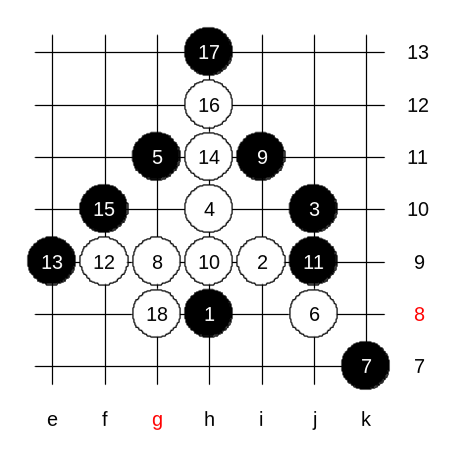
Welcome to the renju class. We may begin our lesson. Today we will learn the last variants of i1 opening. Hopefully we can complete the i1 today. Today's topic is 5th move 5-g11. Actually, white has only two 6th moves here. Does anyone of you know them? concord is right, the choice for the 6th move are i7 and j8. We will learn j8 first. This move is one of the oldest theories in this opening. White is active here, but if black has enough patience, then soon the white activity ends and black gets excellent position. Black blocks the white line from the top. This is a good way to surround white structures. White plays to g9 now. Move 9-i11 seems to be quite safe, but white creates a surprising attack - h9, f9, h11. We cannot underestimate white's attacking power in such situations. What should black do now? Any ideas? You suggest f10, lets try it. White attack is too strong. White had a chance to play g8 because black has no active structures on the board. So, it seems that 15-f10 is wrong move. Lets try to search for the better 15th move.

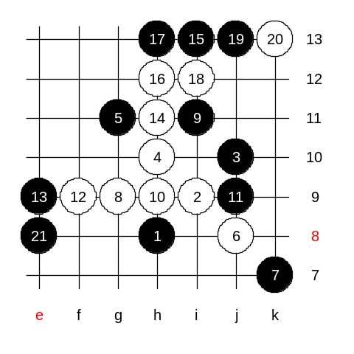
I am waiting your ideas. Actually, there is only one possible 15th move. Yes, i13. That way black gets rid of the 3-3, and takes white diagonal line under control, and also creates some base for black's activities. Since white cannot attack, so white has to defend. Do you want to guess the next black move? Indeed, since black has no straight attack on the upper side, black has to balance the structures on the lower side of the board. Move e8 is the best, I guess. It blocks white last attacking material and makes black base very promising on the lower side as well. As a result, black has got very satisfying position. Black has good structures in all sides of the board. I think, no matter where white plays, black has fair chance to carry out very powerful attack and probably even win later. Because this is not some kind of "sure-win" variant, so we don’t need to continue with further steps here. Anyone can play the following moves by himself or in games with his friends. Any questions about it?
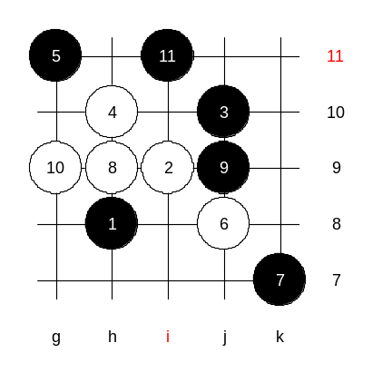
Lets change the 8th move.
8-h9.
This move cannot be underestimated. Move 9-g9 looks so natural, but in fact white gets very good position after that with 10-i7. Therefore black plays usually 9-j9. White 10-g9. And after 11-i11 the position becomes identical with what you just learned before.

It is time to learn the best white move in i1 opening.
6-i7.
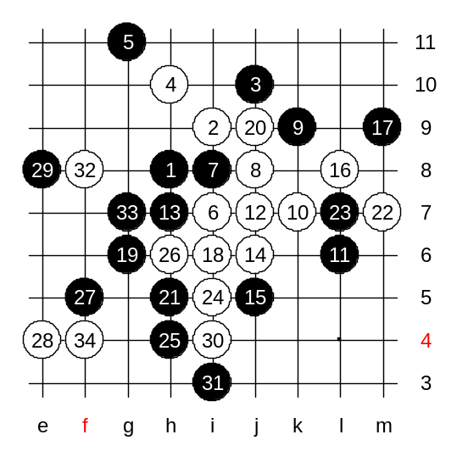
The 7th move is forced - any other 7th move loses fast. Now, it is pretty obvious that white will play either g8 or j8. Move j8 is more active, lets try it first. This is exactly the position where black needs cool head and patience. Black has to defend patiently for a while, whereas any wrong move would lead to immediate loss. White will begin the straight attack. If 15-j9 then white traps the 3x3 at m7. By the 18th move white has finished the straight attack. Now it is black's turn to do something. Many players often make a mistake here though. They play 21-h5 which seems good, but actually loses. Lets see how white will win. Anyone found the idea already? Yes, concord is right, m7, i5, h6. Black has to worry about 3x3 at i4 as well as another coming 3x3 at point g5. Yes, and as affine mentioned, there is also a 3x3x3 danger, so black has to play a four first. Move 29-e8 - the last attempt to get rid of the traps. What should white do now? Yes, you are right. White will trap the 3x3.
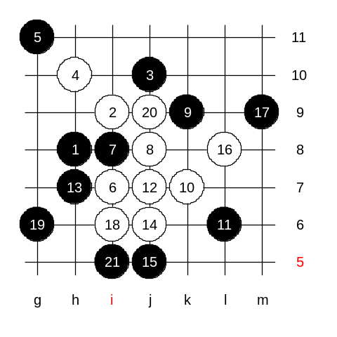

Now, lets look how black should have played instead of that bad 21st move. Move 21-i5 is the correct move. White 22-h5 now. The position after 23 moves: White attack is dead. Black has surrounded white structures and probably will win later in upper side. Upper or left side.

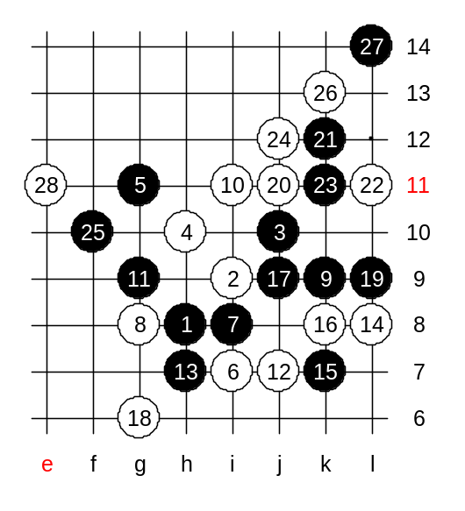
As I want to finish with i1 today, lets take a quick look at the best 8th move, too. Move 8-g8 is much better than 8-j8. The best 9th move is k9. 10-i11 is an obvious move. 11-g9 is obvious too. Now, black has some promising structures on both left and right side. White cannot simply just go and defend either side. White has to be active in order to create more stones and structures on the board and weaken black space with that. 12-j7! 14-L8! White keeps up the tempo. Black has to continue defending. Indeed, this is the most difficult struggle in this opening. But this is exactly the place where white can struggle and finally get the advantage. By the 20th move the situation is following: White has managed to block everything on the right side, and also create some helpful stones to reduce black advantage on the left side. Move 21-k12 just neutralizes white structures with the price of black's right side material. 24-j12 - very good. White does not let black come out from the right corner. Black last attacking attempt is 25-f10. White will use this moment to play a four first. In the history, there have been several games where white has made a wrong next move (28th). First, I teach you the correct 28th move and leave the wrong 28th move as homework. 28-e11 - correct move. After that. black attack is almost dead and the further game will continue under white's domination. Usually, white wins the games after such 28th move.
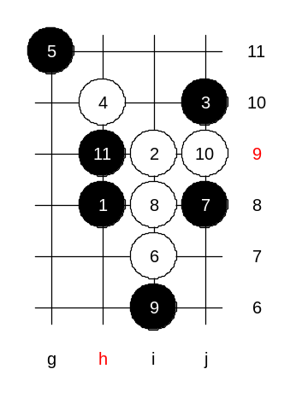

Medium level homework:
Please find white win here. Write the answer into dat file and send the homework answer to me by email.

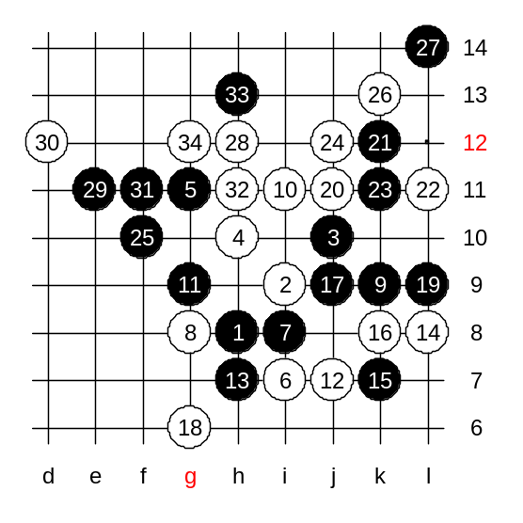
Advanced level homework:
Move 28-h12 is the move that many players have played before, but it actually gives black win. Lets play a few more moves to make it easier for you. 34 stones are on the board now. Please find black win here. Write the answer into dat file and send the homework answer to me by email. The class is over, thank you all for coming, see you next week!

